Comparison between Blazor WebAssembly (WASM) and Blazor Progressive Web App (PWA)
High-Level Concept
Concept | Meaning
Blazor WASM | A hosting model where the Blazor app runs entirely in the browser using WebAssembly
Blazor PWA | A feature set that adds installability, offline support, and caching to a Blazor WASM app
Key takeaway:
Blazor PWA = Blazor WASM + PWA capabilities
Blazor WebAssembly (WASM)
What it is
Blazor WASM allows you to run .NET code directly in the browser using WebAssembly, without requiring a server for UI rendering.
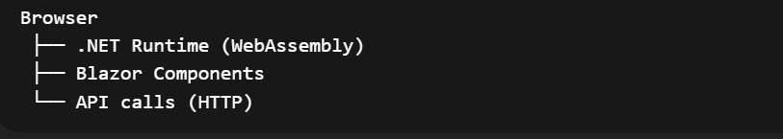
Key Characteristics
Aspect | Description
Execution | Runs fully in the browser
Server dependency | Only for APIs
Offline support | ❌ Not by default
Installable | ❌ No
Performance | Initial load can be slower
Hosting | Static hosting (Azure Static Web Apps, IIS, etc.)

Typical Use Cases
- SPA applications
- Client-heavy UI
- API-driven systems
- SaaS dashboards
Blazor Progressive Web App (PWA)
What it is
A Blazor WASM app enhanced with PWA features, enabling it to behave like a native application.
What PWA Adds
Feature | Provided By
Install on device | Web App Manifest
Offline support | Service Worker
Asset caching | Service Worker
App-like UI | Full-screen, icon, splash screen
Faster reload | Cached resources

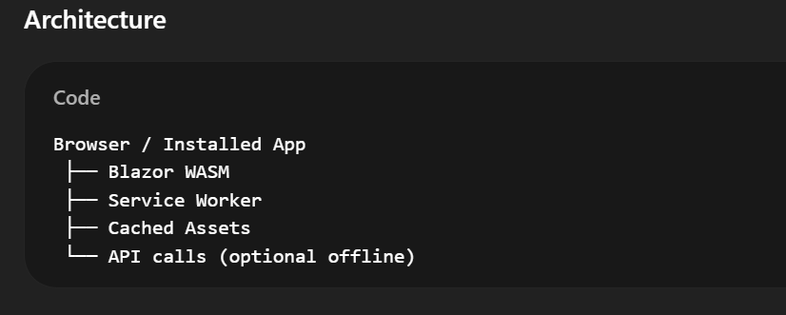
Typical Use Cases
- Mobile-friendly apps
- Offline-first applications
- Field service apps
- E-commerce catalogs
- Internal enterprise tools

Side-by-Side Comparison
Feature | Blazor WASM | Blazor PWA
Hosting model | ✔️ Yes | ❌ No (uses WASM)
Runs in browser | ✔️ | ✔️
Installable like app | ❌ | ✔️
Offline support | ❌ | ✔️
Uses Service Worker | ❌ | ✔️
App icon & splash screen | ❌ | ✔️
Requires internet always | ✔️ | ❌
Mobile experience | Good | Excellent

Project Creation Difference
Blazor WASM (Standard)
dotnet new blazorwasm
Blazor WASM with PWA Enabled
dotnet new blazorwasm --pwa
What the --pwa flag adds:
- service-worker.js
- service-worker.published.js
- manifest.webmanifest
- Offline caching configuration

Real-World Analogy
Technology | Analogy
Blazor WASM | A website running in the browser
Blazor PWA | That same website installed as a mobile/desktop app

